The Fleece of Icelandic Sheep

Icelandic sheep produce a beautiful dual-coated fleece from which the famous LOPI wool is made. The fleece consists of two coats, in natural shades of brown, black, grey and white. One fleece can be made up of several shades or colours. The long, lustrous outer coat is called TOG, and the fine downy-soft inner coat, not unlike mohair, is called THEL. This two-layered fleece is a key factor in the hardiness of these sheep in the harsh wet, cold, and wind of Iceland. These same characteristics are what make the wool spun from these two coats so wonderfully warm and resistant to wind and rain. A full year’s growth produces TOG of approximately 21 cms in length, and THEL of 6 cms. (range 12-80 microns, Bradford Count over 70-under 46; mean 27 microns, Bradford Count 56)

The coats can be carded and softly spun together to make the familiar Lopi-style wool, or finer wools of various weights. The two coats can be separated by hand, or with a hackle, or Viking combs for use alone, or to blend with other fibres. The tog can be spun into warp or rug yarn, or used for embroidery. The soft thel can be spun into a baby-soft wool or combined with other fibres.

The fleece is well known for its ease of felting. Boots, mittens and garments are often felted in Iceland to produce beautiful as well as durable products. It felts easily and quickly and adds strength and firmness to other wools. Take care when washing Icelandic fleece and handle it gently. Don’t agitate the water, and only squeeze excess water out rather than wringing the wool, because of its ease of felting.

There is not a lot of grease in the Icelandic fleece, so unless the fleece is very dirty, a gentle wash / rinse / and rinse again is adequate.

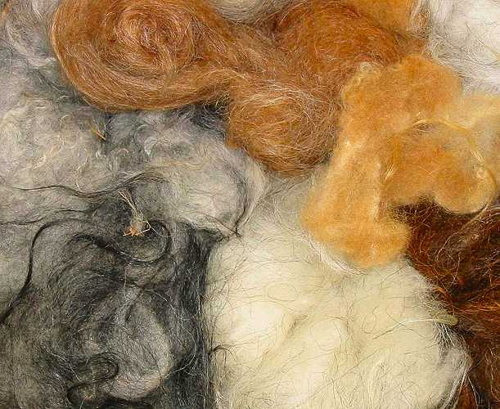
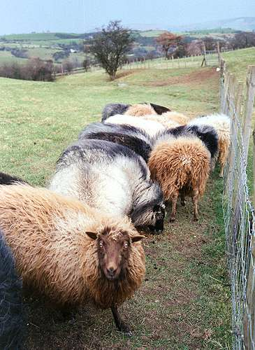
Icelandic sheep are a pure, unique breed, protected by isolation for centuries. The fleece, likewise, is unlike any other, anywhere….

Wool as nature intended it to be!

Cae’rddraig Icelandic Sheep
www.icelandicsheepinwales.co.uk

